Weather API Application

Contents
Weather API Application 1
Purpose of document: 2
Technologies/Tools used: 2
Steps to install the required softwares: 3
Project Architecture Overview 5
Creating a Microservice: 6
Weather application Microservices: 9
End Points: 10
Testing an Endpoint: 10
Verifying data using MongoDB Compass: 11
Sample screenshots of Weather Application 12
Steps to setup application locally 15
Section-1: Steps to import code from Bitbucket to Visual Studio Code 15
Section-2: Steps to import microservices in STS Editor 16
Section-3: Steps to start Kafka and Zookeeper servers 18
Section-4: Steps to start microservices from STS 19
Section-5: Steps to start the application from Visual Studio Code 21

Purpose of document:
The purpose of this document is to provide a step-by-step detail for building weather application using microservices framework.

Technologies/Tools used:
- Spring Boot
- Spring Boot is considered as the best framework to develop microservices architecture because of its capabilities like straightforward service discovery registry, easy central configuration service creation, embedded servers, dependency injections etc.
- React
- React is a declarative, efficient, and flexible JavaScript library for building user interfaces. It lets you compose complex UIs from small and isolated pieces of code called “components”.
- Netflix components
- Spring cloud Netflix provides Netflix OSS integrations for spring boot apps through auto configuration. With a few simple annotations we can quickly enable and configure common patterns inside application and to build large distributed systems with Netflix components. There are lot of features available with spring cloud Netflix. Here, we have implemented some of the common features like Service Discovery, Service Creation, Routers and filters using ZUUL
- Spring tool suite
- STS is the best environment which is customized to develop spring boot apps as it supports applications to run local as well virtual and cloud based servers and mostly it is fully open sourced and freely available for the development
- Mongo DB Atlas
- Mongo DB Atlas is a cloud-hosted MongoDB service which is fast, secure and highly available. Mongo DB Atlas helps in developing small scale applications easily without worrying about the setup, installation/configuration of MongoDB
- Mongo DB Compass
- Mongo DB Compass is graphic interface tool to display information about a MongoDB database and perform queries. one can easily build queries by clicking on fields and modify data and interact with your data with full CRUD functionality
- Postman
- Postman is great tool to test REST API’s and allows to interact with them

- Visual Studio Code
- Visual Studio Code is a source code editor developed by Microsoft for Windows, Linux and macOS. It includes support for debugging, embedded Git control, syntax highlighting, intelligent code completion, snippets, and code refactoring.

- Apace Kafka
- Apache Kafka is an open-source stream-processing software platform developed by the Apache Software Foundation, written in Scala and Java. The project aims to provide a unified, high-throughput, low-latency platform for handling real-time data feeds. Its storage layer is essentially a "massively scalable pub/sub message queue designed as a distributed transaction log making it highly valuable for enterprise infrastructures to process streaming data. Additionally, Kafka connects to external systems (for data import/export) via Kafka Connect and provides Kafka Streams, a Java stream processing library.
A streaming platform has three key capabilities:
- Publish and subscribe to streams of records, similar to a message queue or enterprise messaging system.
- Store streams of records in a fault-tolerant durable way.
- Process streams of records as they occur.
Kafka is generally used for two broad classes of applications:
- Building real-time streaming data pipelines that reliably get data between systems or applications
- Building real-time streaming applications that transform or react to the streams of data

Steps to install the required softwares:
- Node js and React Installation:
- Node.js can be downloaded from here .
- Select the PC compatible version of Node.js and then install.
- To verify the installation of Node.js type the following command in command prompt: npm --version or node –version.
- Enter the cmd npm i –g create-react-app to download react package.
- Enter the cmd as create-react-app <projectname> to create a project.

- Mongo DB Atlas setup:
To setup Mongo DB Atlas and download compass follow the steps mentioned in the attached document.

- Visual Studio Code:
We have used Visual Studio Code for code development.
Download the latest Visual Studio Code from the location - https://code.visualstudio.com/
- Kafka download and installation:
To setup Kafka please follow below steps
Step-1: Download Apache Kafka software using below URL
URL: http://redrockdigimark.com/apachemirror/kafka/2.0.0/kafka_2.12-2.0.0.tgz
After extracting downloaded zip file, we can see below folder structure
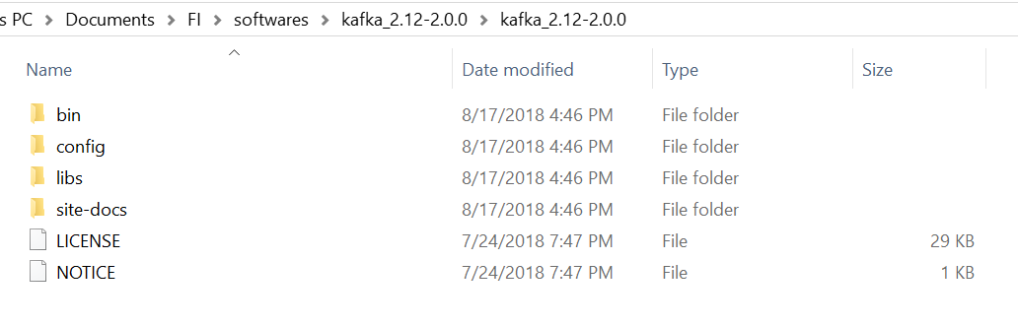
Step-2: Copy Kafka unzipped folder into C drive
Step-3: Open command prompt and navigate to Kafka windows folder (C:\kafka_2.12-2.0.0\bin\windows)
Step-3: Start zookeeper. start bat file with below command
Command: zookeeper-server-start.bat C:\kafka_2.12-2.0.0\config\zookeeper.properties
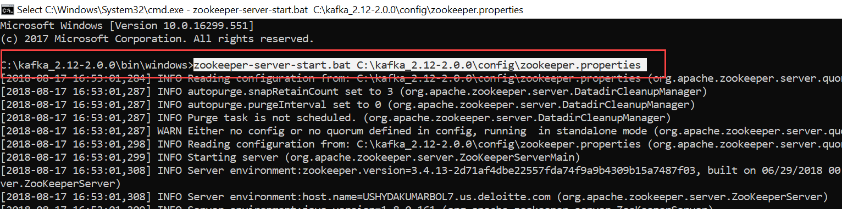

Step-4: Open another Command Prompt and navigate to C:\kafka_2.12-2.0.0\bin\windows folder
Step-5: Start Apache Kafka server with below command
Command: kafka-server-start.bat C:\kafka_2.12-1.1.0\config\server.properties
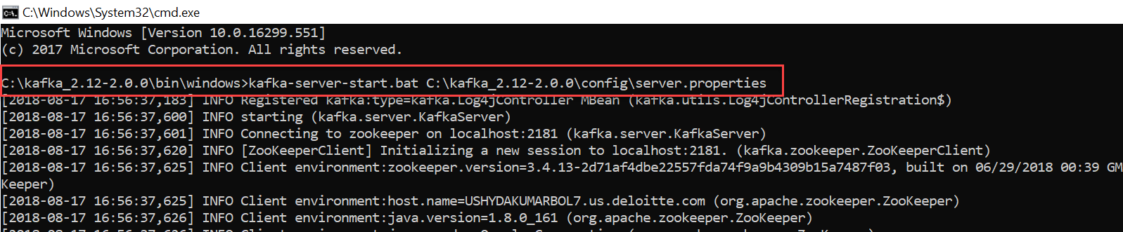
  - With above procedure Apache Kafka Server will be up and running

Project Architecture Overview
Below is the Weather Portfolio Application Architecture

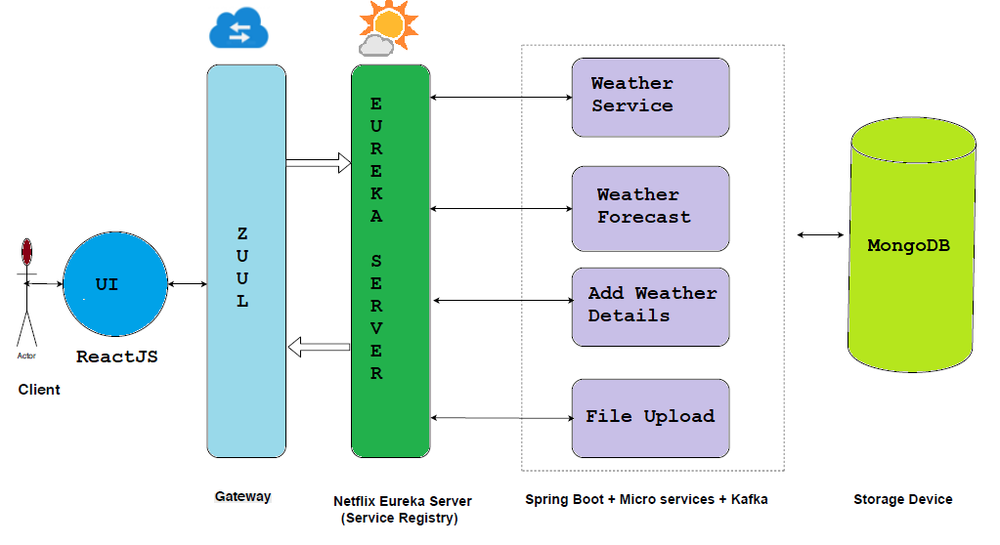

Creating a Microservice:
Microservices can be created using spring boot framework and built around RESTful Resources which will communicate among themselves through HTTP with help of spring dependencies. Let’s see how to create Eureka-Server microservice and register any one of the microservice with it
NETFLIX-EUREKA-SERVER: This service helps other services to register with it for service discovery
Project Structure
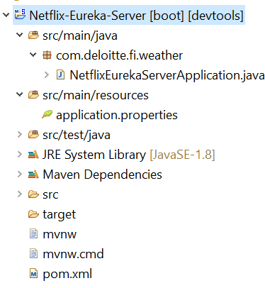

- Details
  - pom.xml: Add spring-cloud-starter-netflix-eureka-server dependency
  - NetflixEurekaServerApplication.java: Add @EnableEurekaServer annotation to spring boot application class to enable eureka.
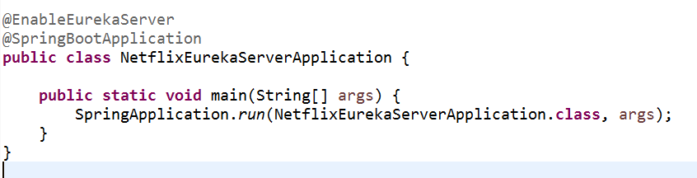
  - Application.properties: Configure the application name and port for the Eureka Server
    - Spring.application.name
    - Server.port

WEATHER-SERVICE: Now let’s create weather service and register it with eureka
Project Structure
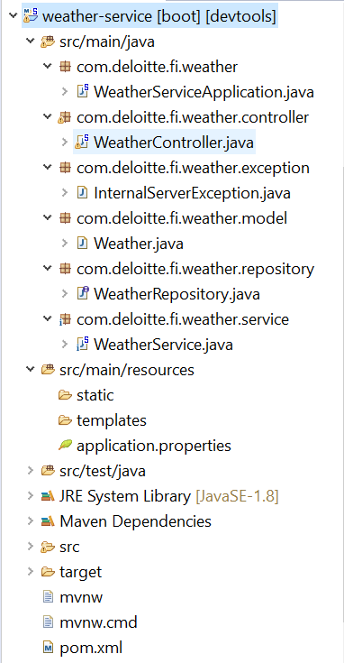
- Details
- WeatherServiceApplication.java - The Spring Boot Application class generated with Spring Initializer. This class acts as the launching point for application and @EnableDiscoveryClient annotation to this class to make it discoverable for other services
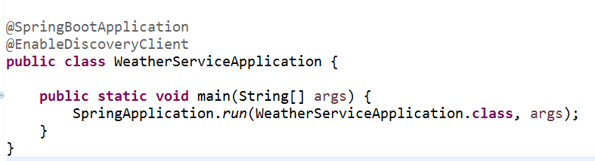
- pom.xml - Contains all the dependencies needed to build this project. We will use the following
  - spring-boot-starter-web: used to create the Rest Controller
  - spring-cloud-starter-netflix-eureka-client: used for service discovery
  - spring-boot-starter-data-mongodb: used for MongoDB connection
- Weather.java-Weather entity
- WeatherRepository.java-Uses CRUD Repository to perform all CRUD operations
- WeatherController.java-Spring Rest Controller exposing Weather Service
- WeatherService.java – Spring Service used to perform any operations
- Application.properties-The following properties needs to be set
  - server. port: The server port on which microservice will run
  - spring.application.name: Name of service to be registered with EUREKA
  - eureka. client. serviceUrl.defaultZone: Eureka service URL
  - spring.data.mongodb.uri: MongoDB connection URL
    - we need to get the MongoDB connection URL from the MongoDB Atlas, a cloud hosted service

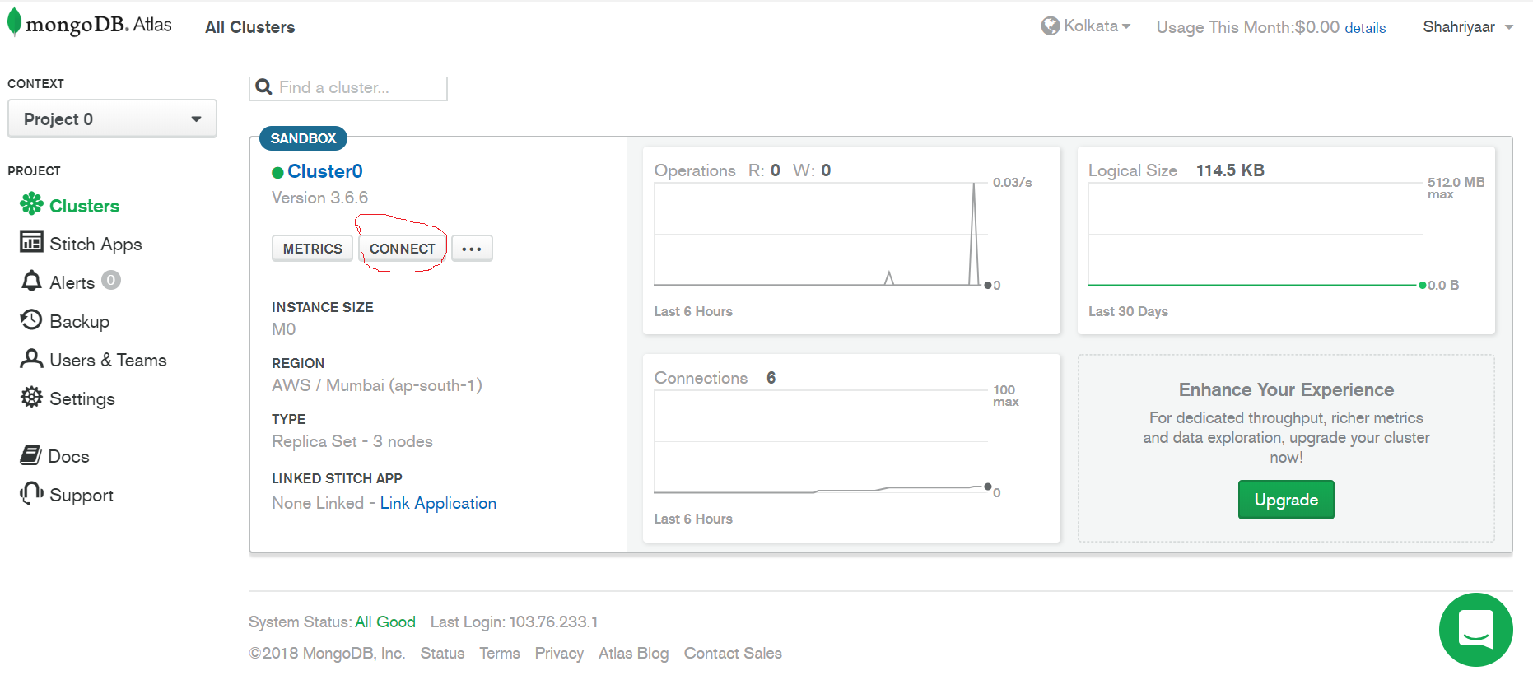

- Once all the microservices are up and running, we can see that all the services got registered with EUREKA-SERVER.

Local URL : http://localhost:8761/

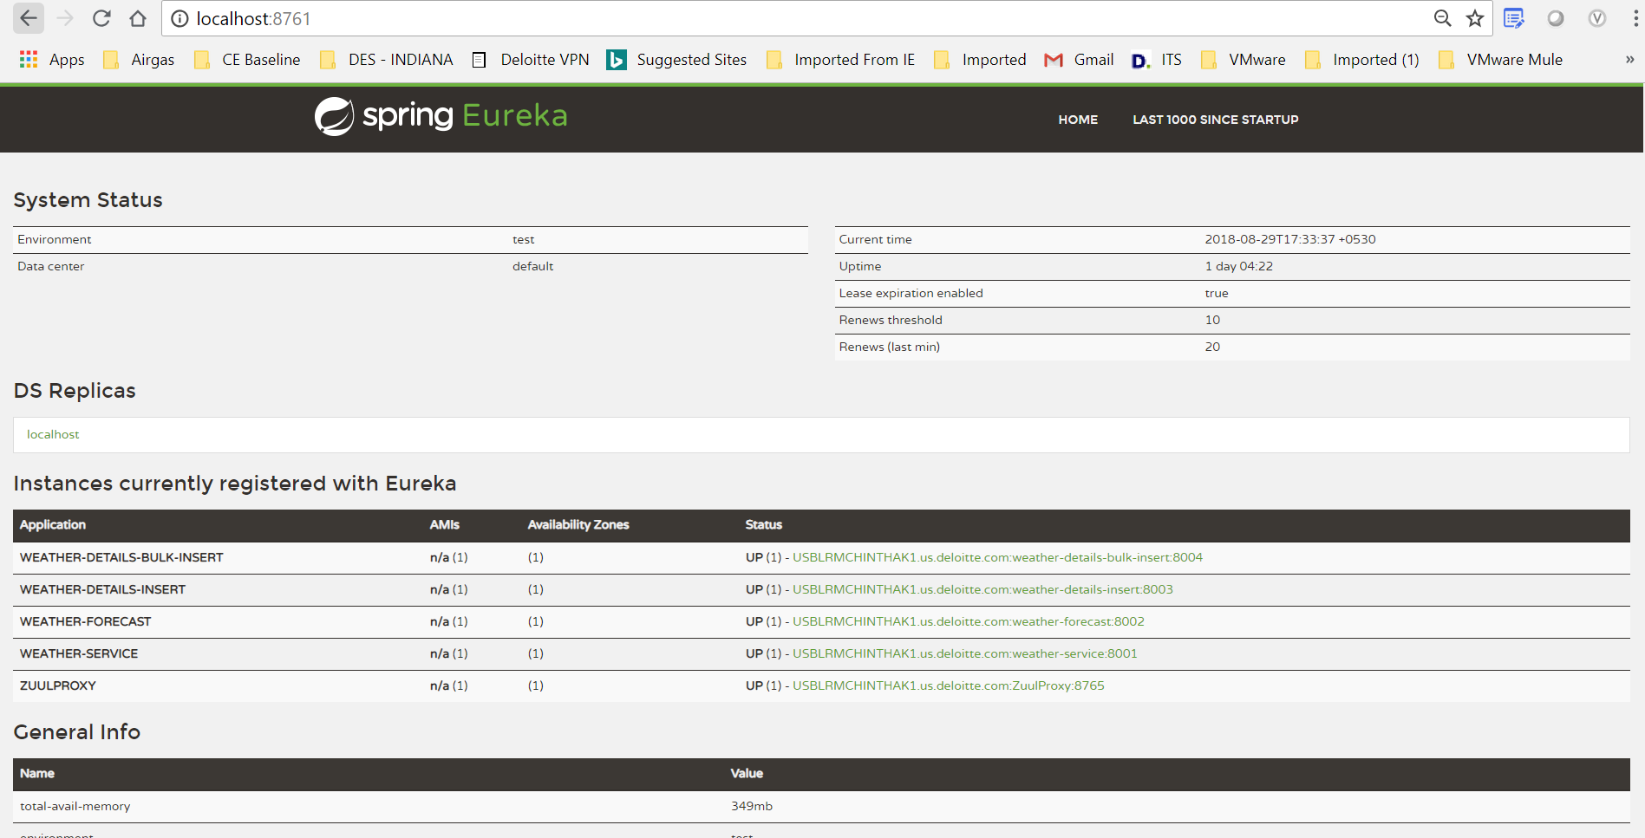

Weather application Microservices:
We are developing a Weather application as a suite of small services (Micro services) each running in its own process and communicating with lightweight mechanisms, often an HTTP resource API. The Entire application is divided into following microservices

WEATHER-SERVICE: This service will fetch the details of weather based on a particular date and a city name.
WEATHER-FORECAST: This service will fetch the details of weather forecast based on range of date and a city name.
WEATHER-DETAILS-INSERT: This service inserts the details of the weather for a particular city and a date.
WEATHER-DETAILS-BULK-INSERT: This service inserts the weather in bulk using Kafka. It takes the data of various cities and dates in the form of a file and persists it into the database.
NETFLIX-EUREKA-SERVER: This service helps to register all the above services and helps to communicate among themselves through service discovery

End Points:
Microservice | Http Method | End points | Comments
Weather-service | GET | /weather | Get All weather details
Weather-service | GET | /weather /citydate/{city}/{date} | Get weather details for a particular city on that date
Weather-forecast | GET | /forecast/{city}/{fromdate}/{todate} | Get the weather forecast details for a particular city for the date range.
Weather-details-insert | POST | /insert | Adds the weather details of a city
Weather-details-bulk-insert | POST | /bulkInsert/upload | Uploads all the weather details in a bulk manner/

Testing an Endpoint:
We can test the above endpoints that we created using postman
Let’s test following weather-service endpoint
GET: we got weather details for the mentioned city and a date
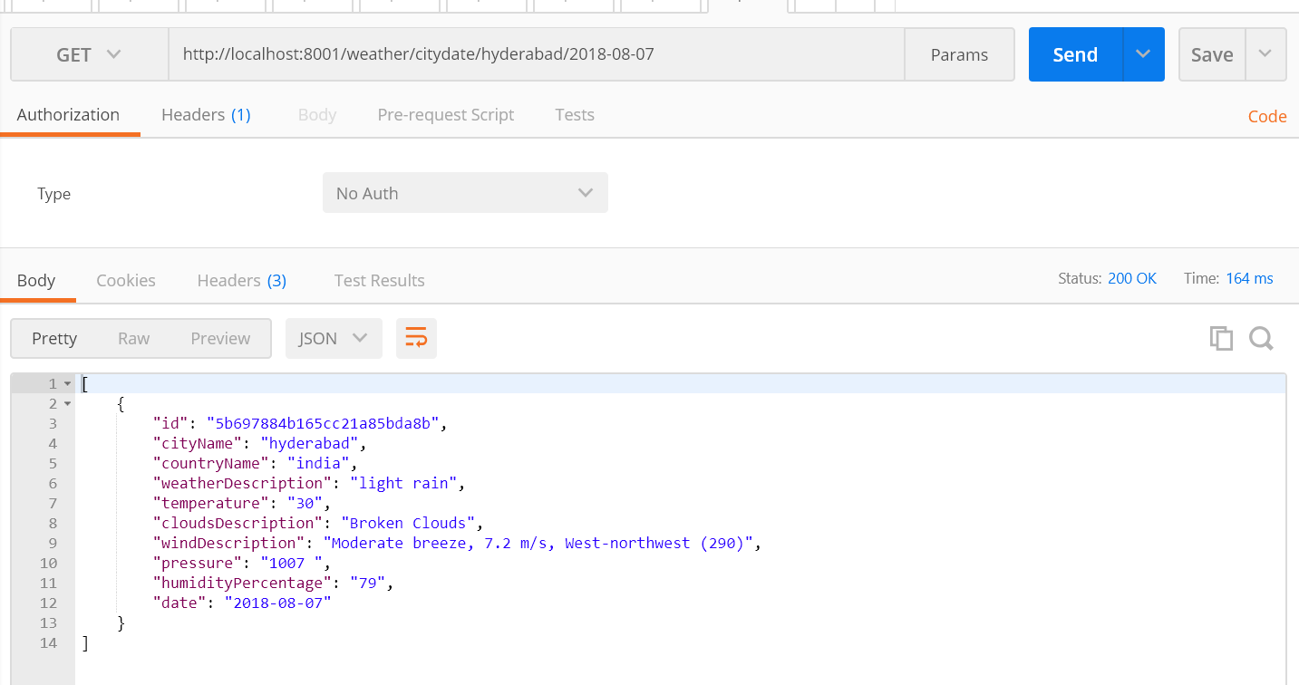

Let’s test for weather-details-insert endpoint.
POST: we insert the details into db successfully.
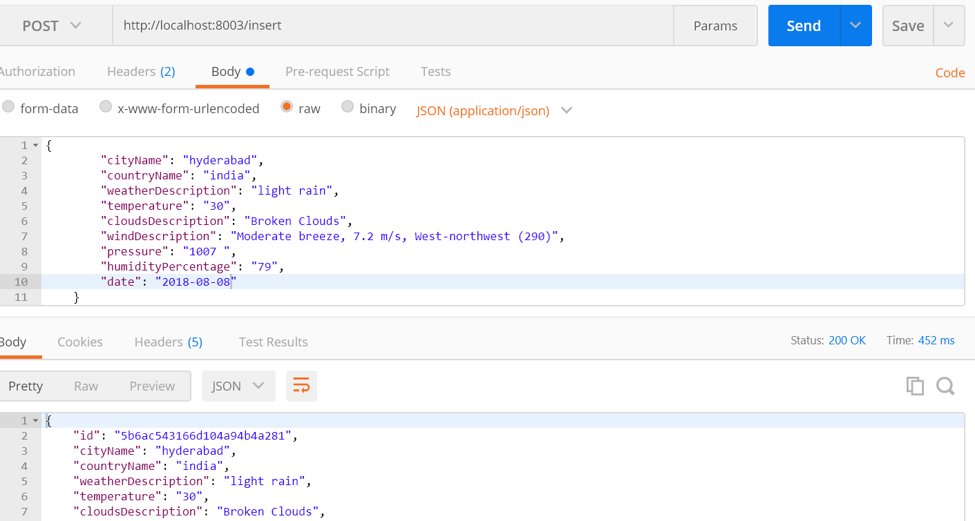

Verifying data using MongoDB Compass:
We can verify our data in MongoDB that we created using Postman API using MongoDB Compass
Connect to MongoDB Compass with your MongoDB Atlas Connection String
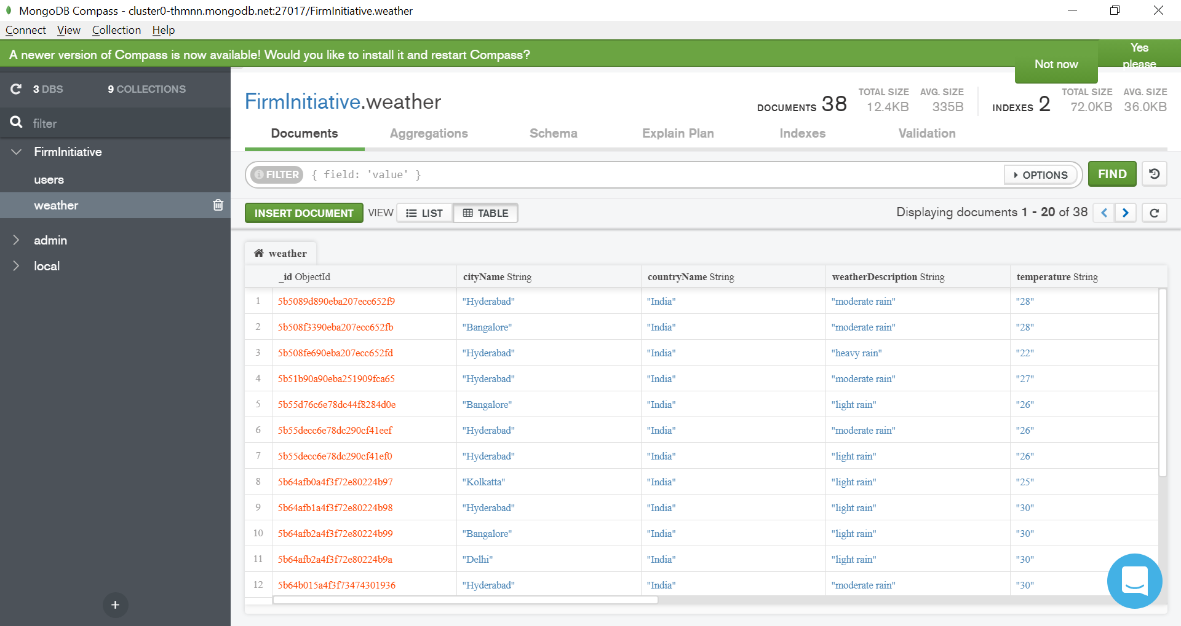
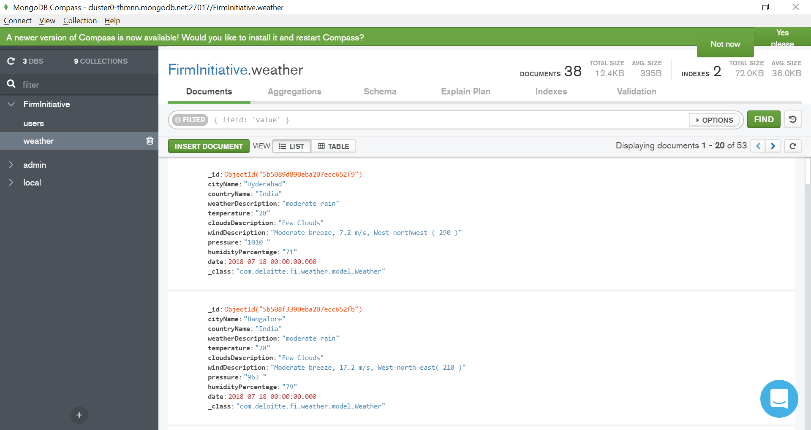

Sample screenshots of Weather Application

Dashboard Screen
Below screen displays dashboard of the application
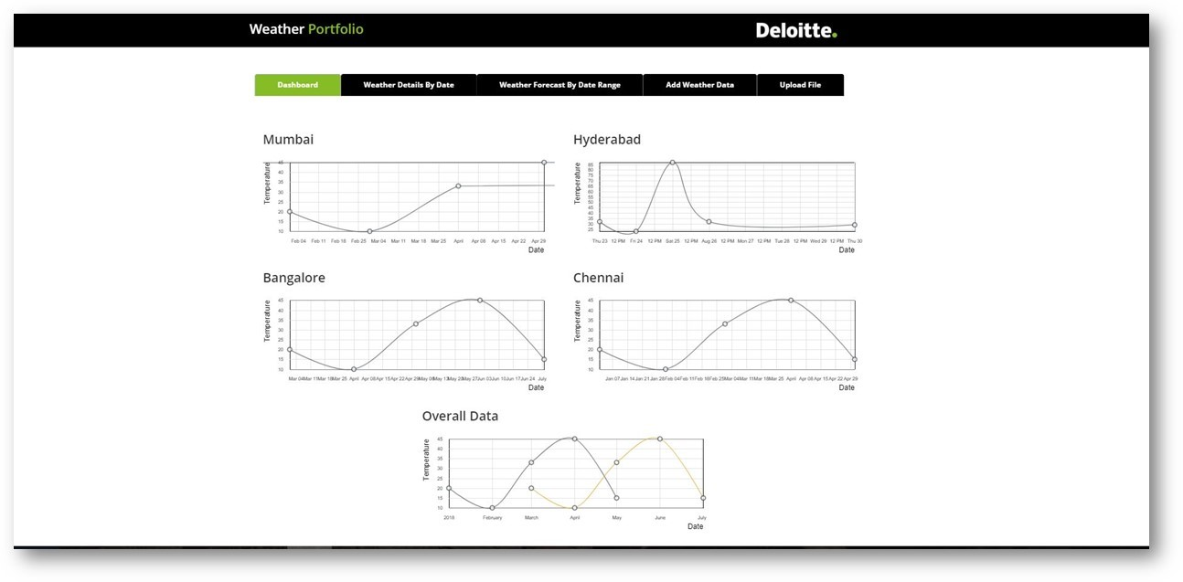

Weather Details By Date Screen
Below screen is used to search city specific weather data for given date
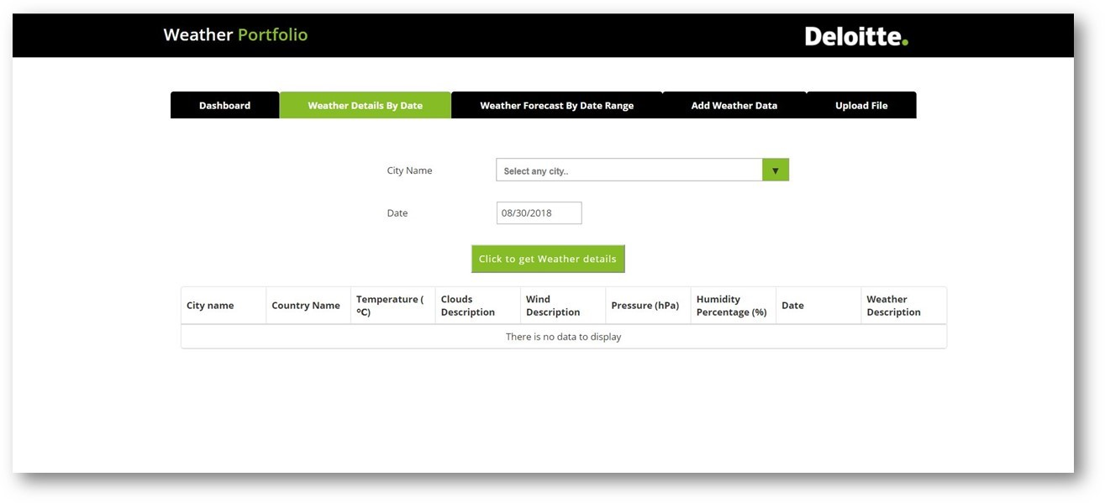

Weather Forecast By Date Range Screen
Below screen is used to search weather forecast information for specific city with date range

Add Weather Data Screen
Below screen is used to add Weather data into application manually
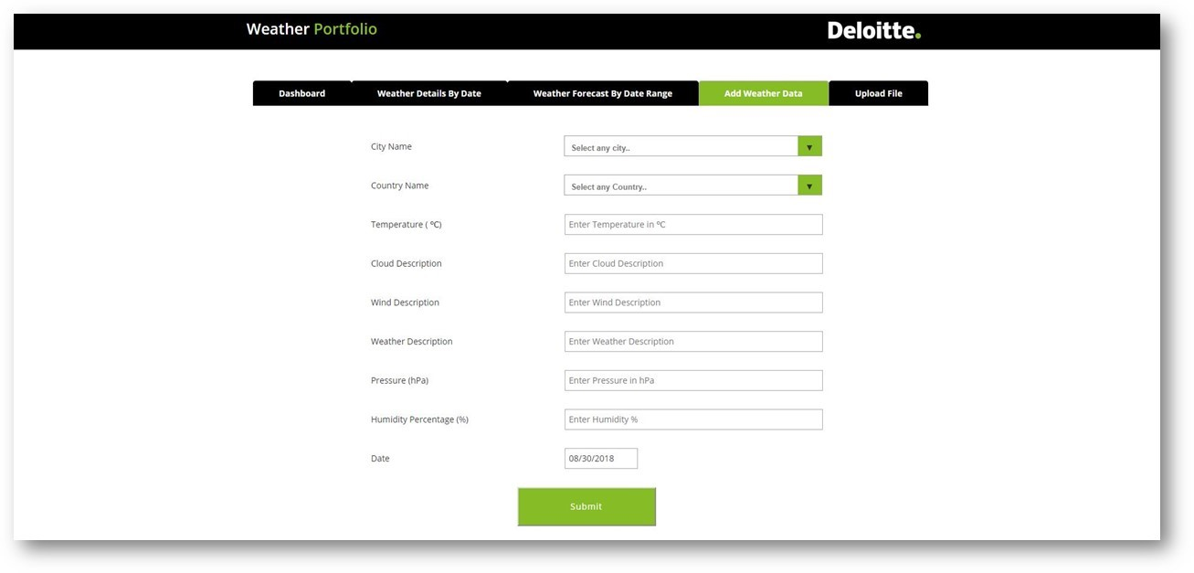
Upload File Screen
Below screen is used to upload weather details file into application (Bulk insertion)
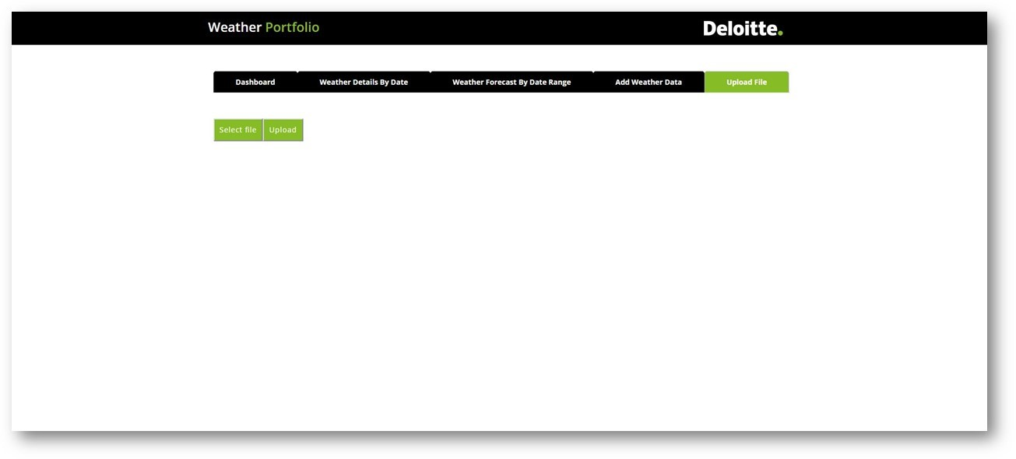

Steps to setup application locally
  - First get the latest code from bitbucket to Visual Studio Code Editor using the steps given in Section-1.
  - Now import all the microservices to STS editor using the steps given in Section-2.
  - Then start Zookeeper and Kafka servers using the steps given in Section-3.
  - After that start all microservices in the below order from STS using the steps given in Section-4.
- Netflix-Eureka-Server
- ZuulProxy
- weather-service
- weather-forecast
- weather-details-insert
- weather-details-bulk-insert
  - Finally start the application from Visual Studio Code editor using the steps given in Section-5.

Section-1: Steps to import code from Bitbucket to Visual Studio Code
- Open Visual Studio Code Editor
- To clone bitbucket code open Command Palette (Ctrl+Shift+P) in VS Code and then type the command Git: Clone

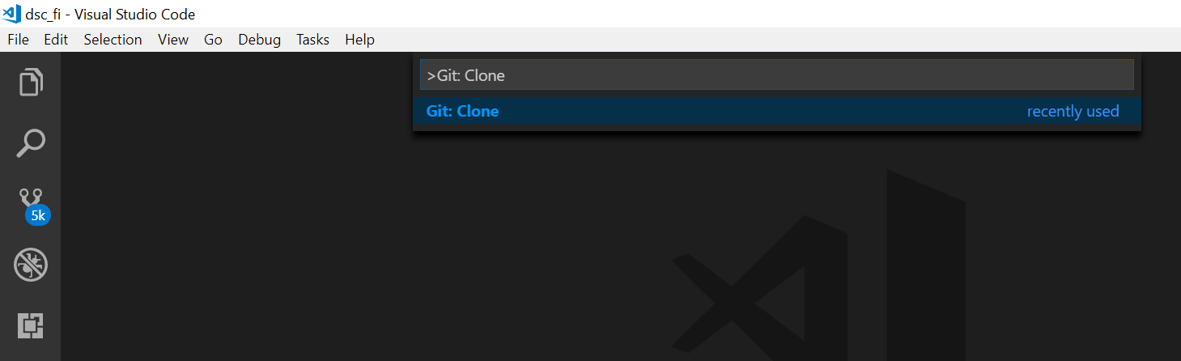

- Now give the URL of the remote repository and the parent directory under which to put the local repository.

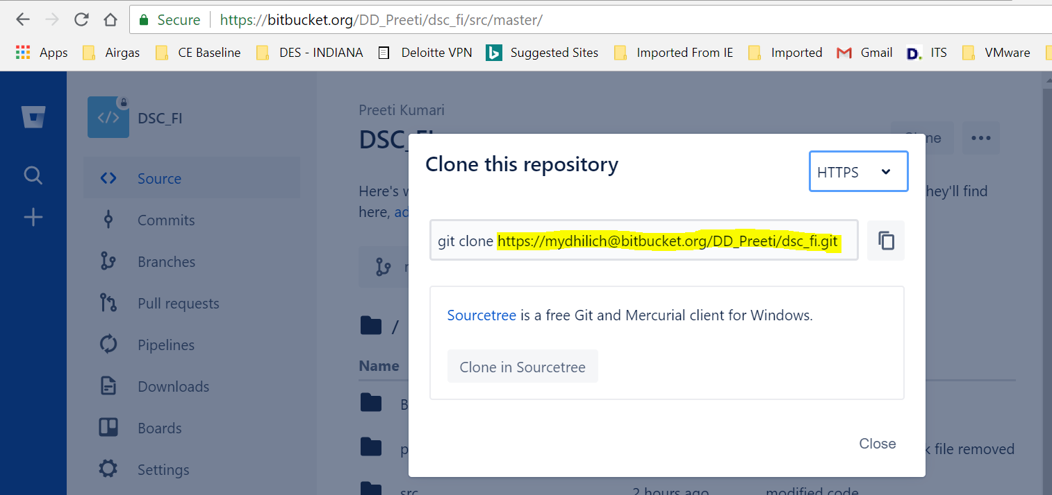
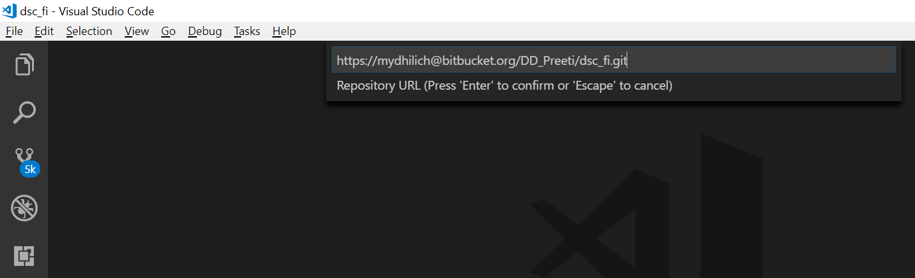

- After importing we can see the below project structure in Explorer
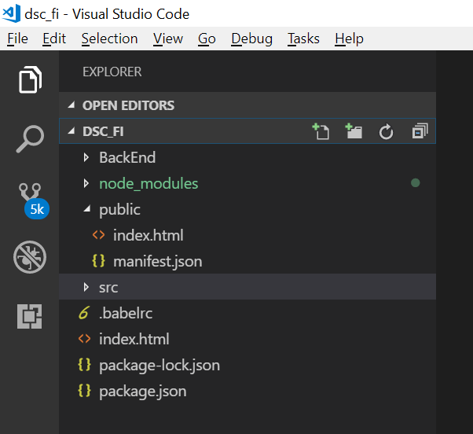

Section-2: Steps to import microservices in STS Editor
  - Open STS editor and then open File -> Import -> Maven -> Existing Maven Projects
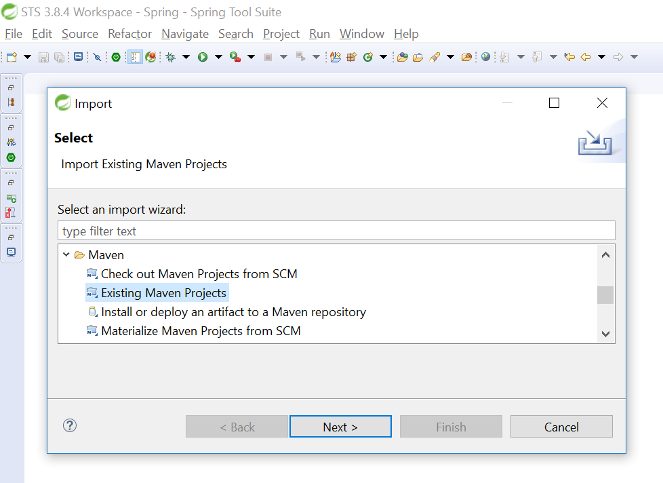
  - Browse and select the microservice that you want to import into STS
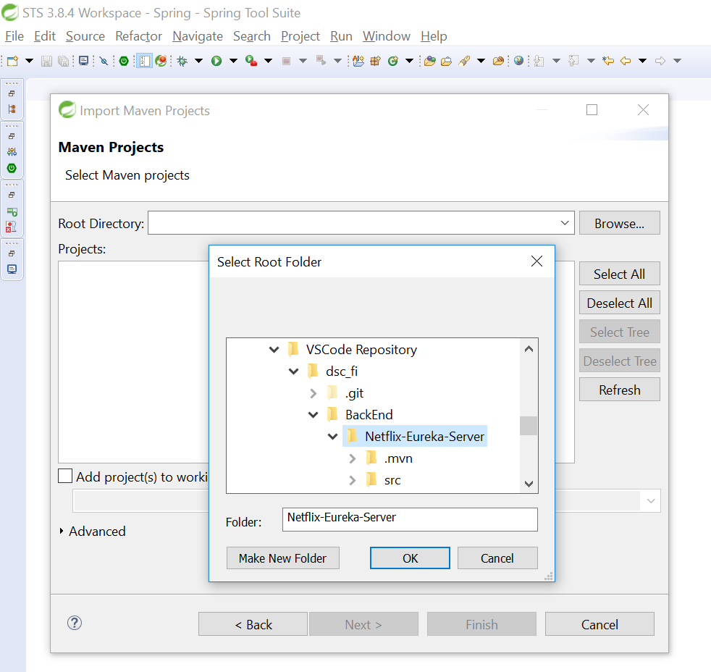
  - Select pom.xml file and then click on Finish button
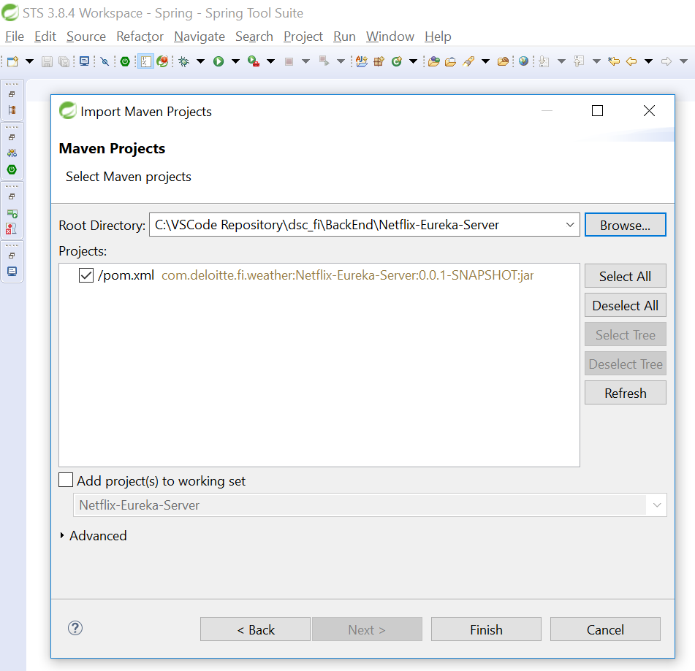

Section-3: Steps to start Kafka and Zookeeper servers
  - Open command promt
  - Navigate to Kafka installation folder (Ex: C:\kafka_2.12-1.1.0)
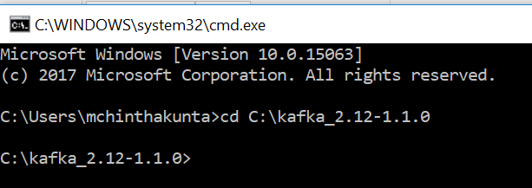
  - Execute below command to run Zookeeper
.\bin\windows\zookeeper-server-start.bat .\config\zookeeper.properties

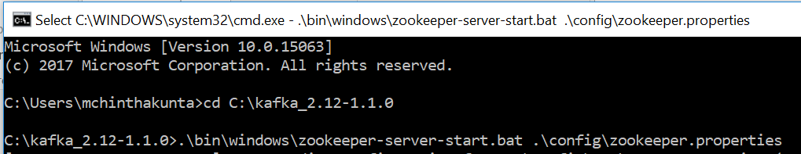

Zookeeper started successfully
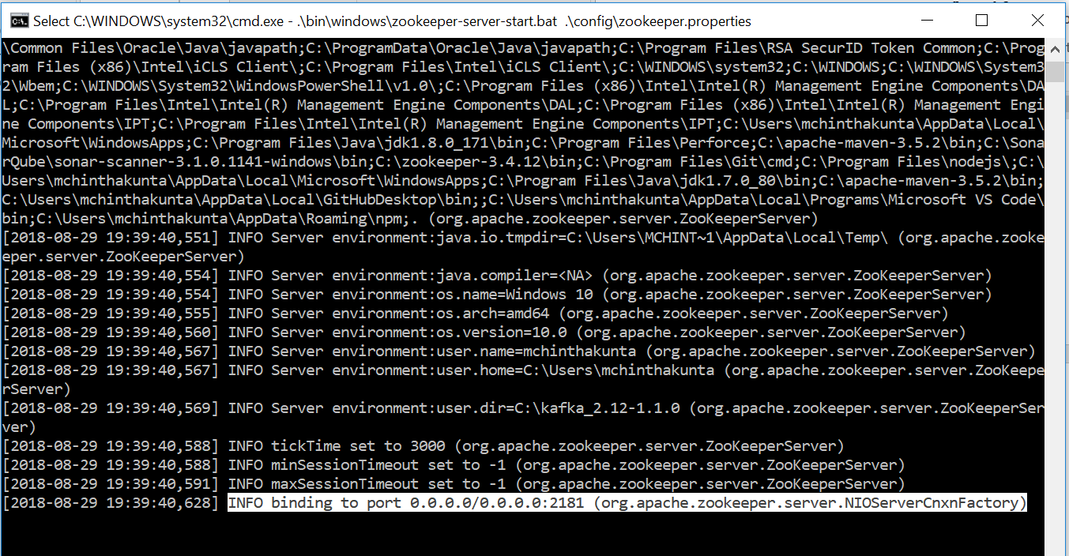

  - Open new command prompt and navigate to Kafka installation folder.
  - Execute below command to run Kafka server
.\bin\windows\kafka-server-start.bat .\config\server.properties

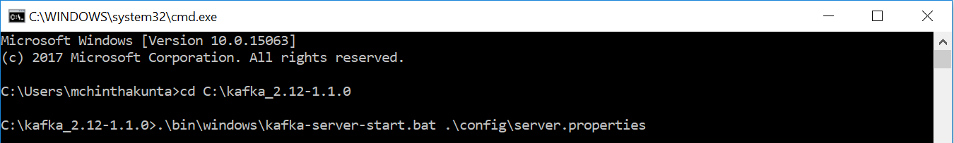

Section-4: Steps to start microservices from STS
  - Open STS and right click on the microservice that you want to start
  - Click on Run AS -> Sprint Boot Application
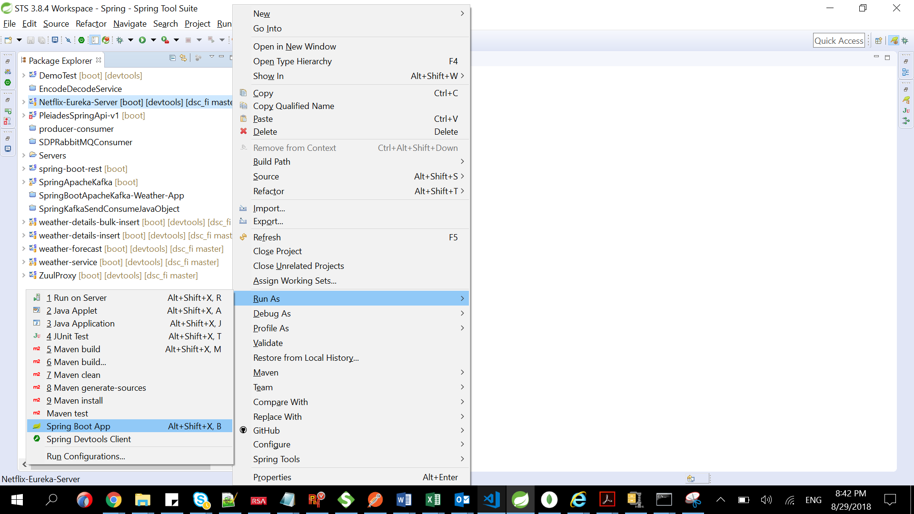
  - We can see from console that service is started successfully
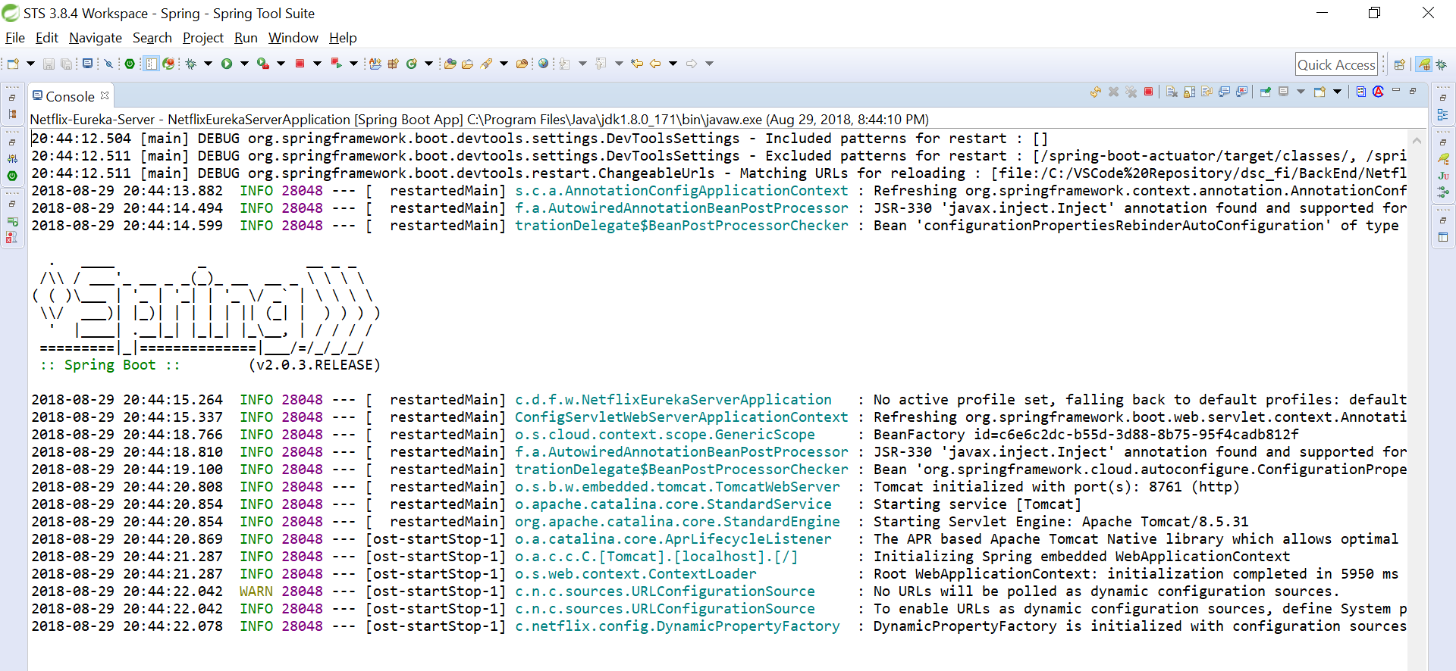
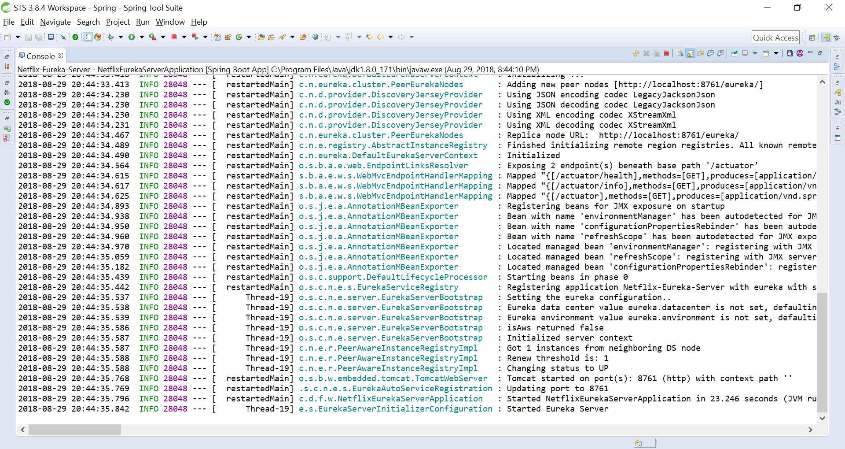
  - Once all the microservices are started from STS we can check if those services are registered with Eureka using the below url
http://localhost:8761/

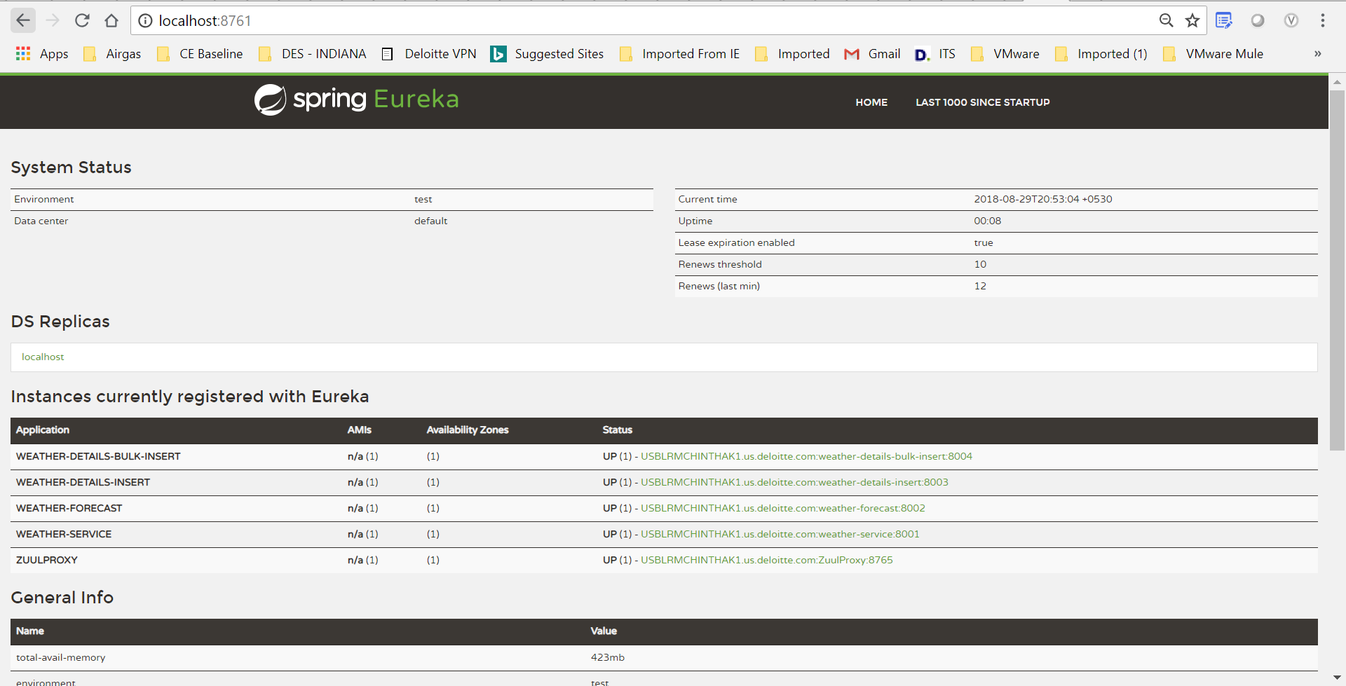

Section-5: Steps to start the application from Visual Studio Code
  - Open Terminal in Visual Studio Code from View -> Terminal

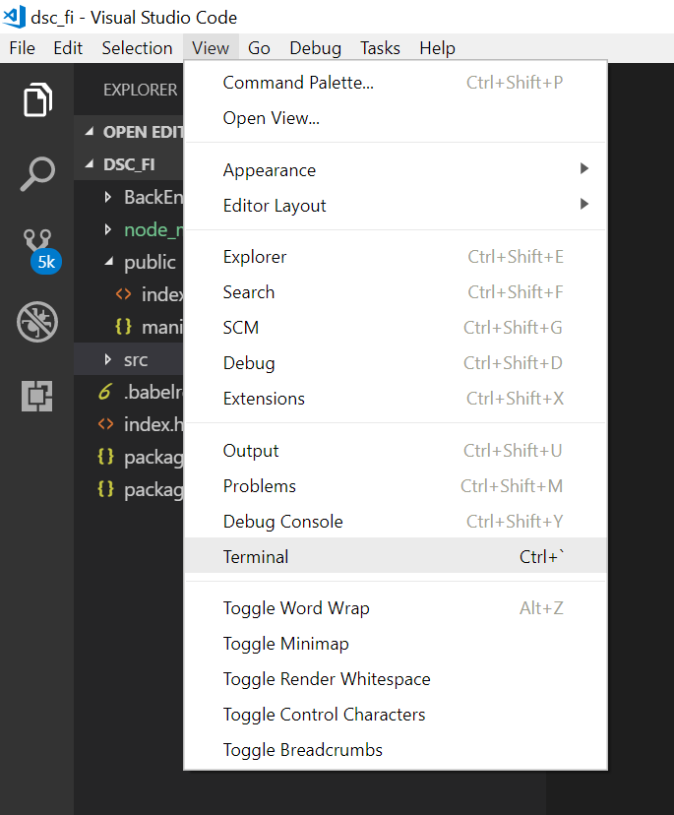
  - Now type the command “npm i”
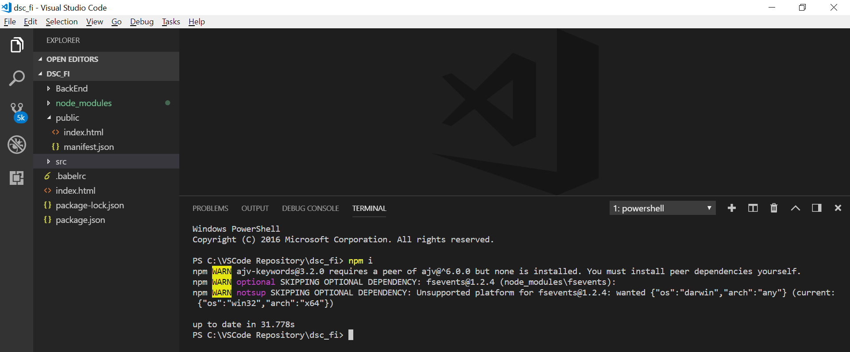
  - Then start the application using the command “npm start” in Terminal
  - It opens the application automatically on your browser on the below url
http://localhost:3000/

